  AMS PD Labs | 

AMS Physical Design Labs
Lab 8

‘Team Work’

Objective
To promote collective team work by working on separate blocks individually to complete final block
To mimic real life experience where each block can be sometimes dependent on other blocks in layout design

Procedure:
- Build XNOR using NAND and NOR gates (Not AND / OR)
- Team must divide to 5 each person will build his own design.
- Each person must fill in his sheet required information.
- Designs must be saved and named to a specific location requested on sheet
- Designs must be built manually (Generate from lib is allowed).
- All designs must use (Old version RUL file).
- Each design must be DRC and LVS clean.
- Submit with each design a printout of layout / working simulation / schematic / true table / Area used.
- Do not use DSCH SW to compile designs but you can use it to verify designs.
- Write down any errors found in this assignment to help improve the forms.
- If you have any questions, please let me know.
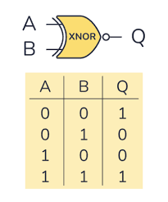

Name: Layan Salem Design Area WxL =24x37

Design: NOT Gate CMOS logic 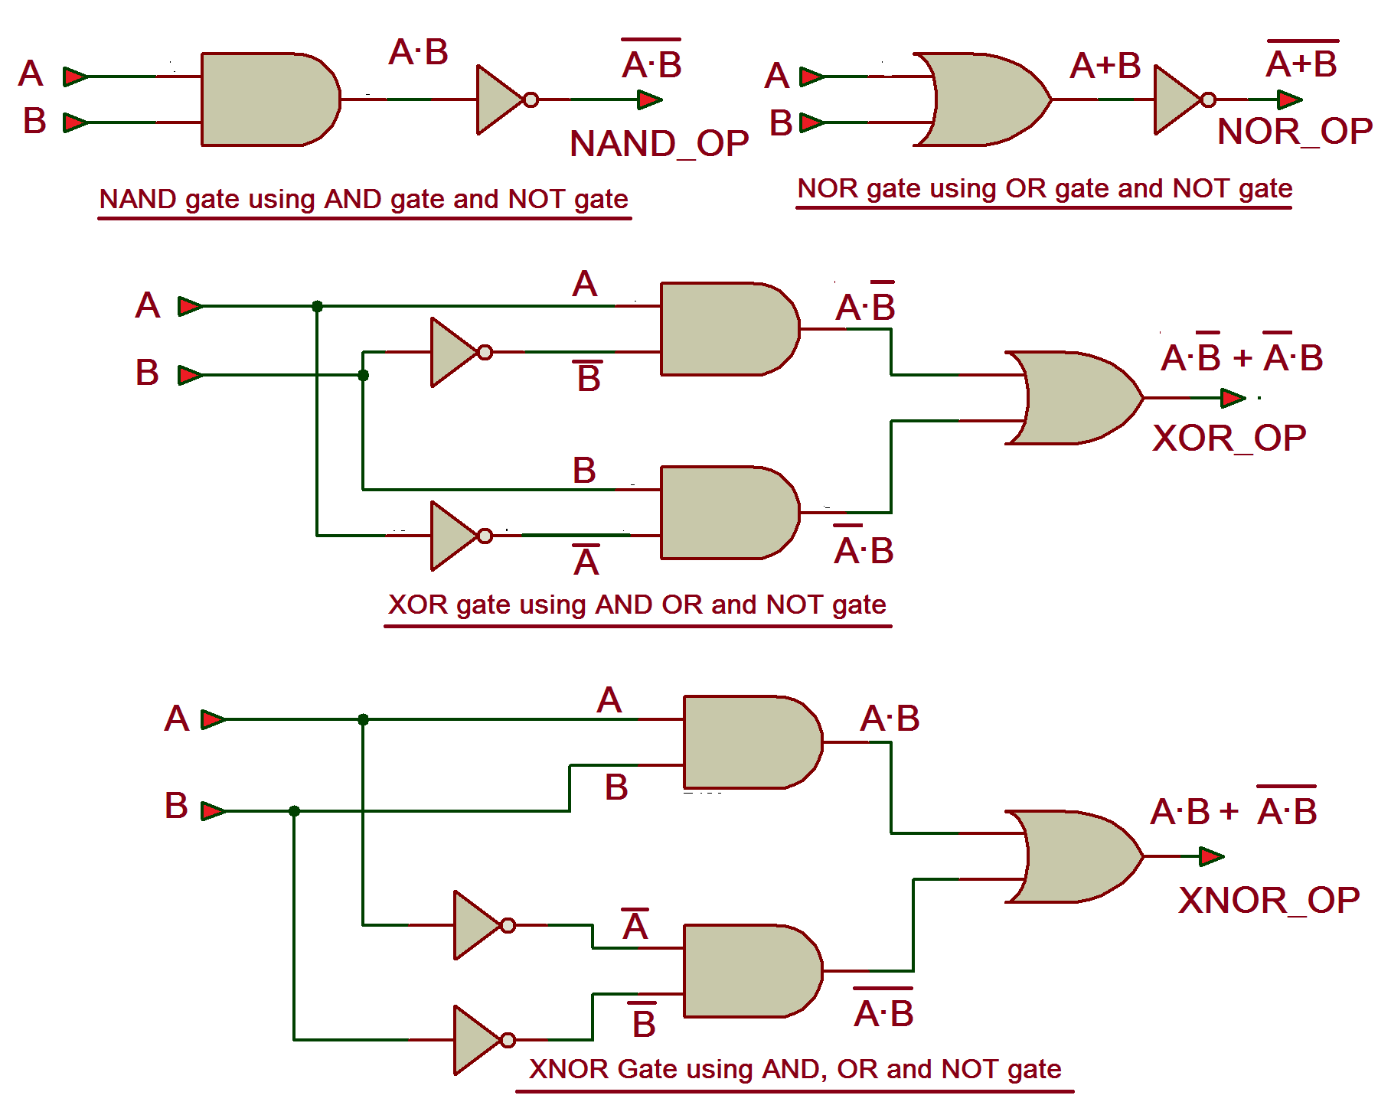

- Please build design for circled logic above.
- Save design with Inverter_ (Your first name).MSK on desktop
- Send design to person building the next logic when needed.

Please insert a picture of CMOS schematic below.
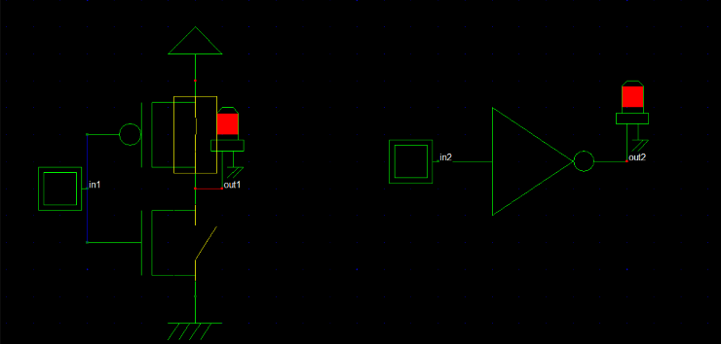
Please insert picture of DRC clean layout below.
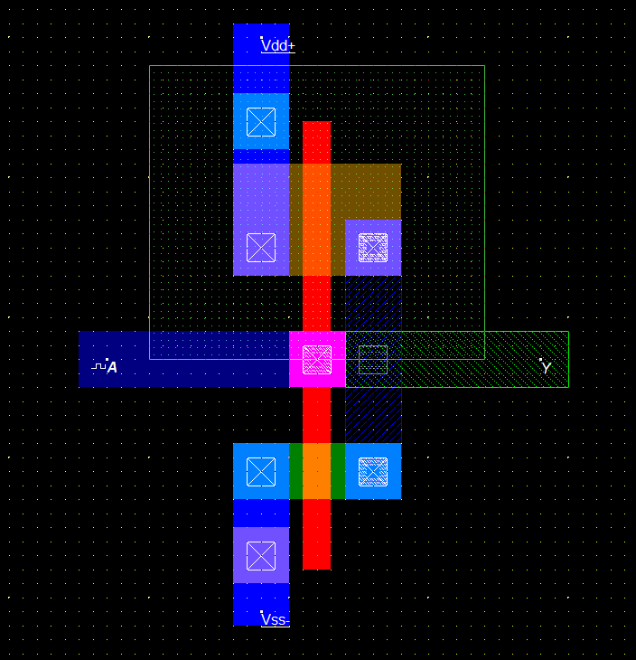

Please insert a picture of working simulation below.
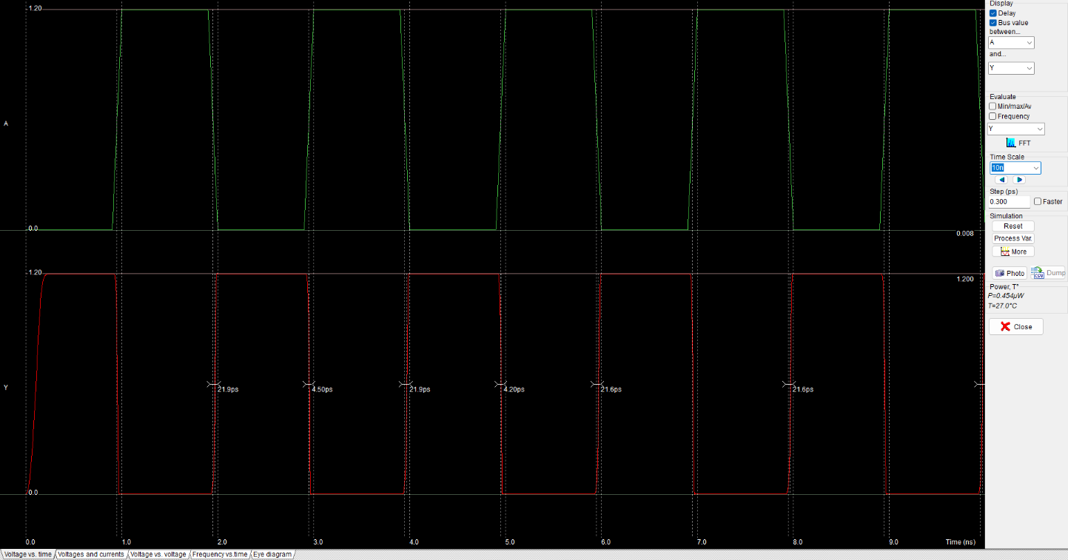
Fill in True Table according to Simulation
A | OUTPUT | Accomplished YES/NO
1 | 0 | YES
0 | 1 | YES

Name: Sadeen Faqih Design Area WxL = 70x40

Design: AND Gate CMOS logic 

- Please build design for circled logic above.
- Save design with AND_ (Your first name).MSK on desktop
- Send design to person building the next logic when needed.

Please insert a picture of CMOS schematic below.
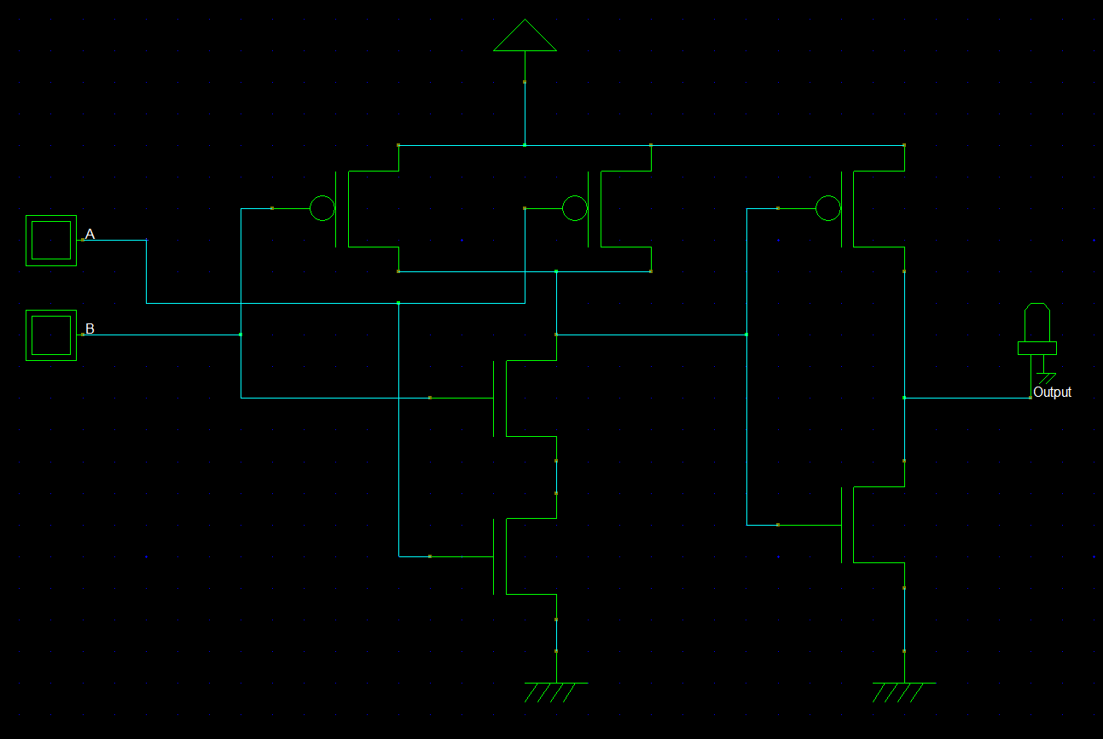
Please insert picture of DRC clean layout below.
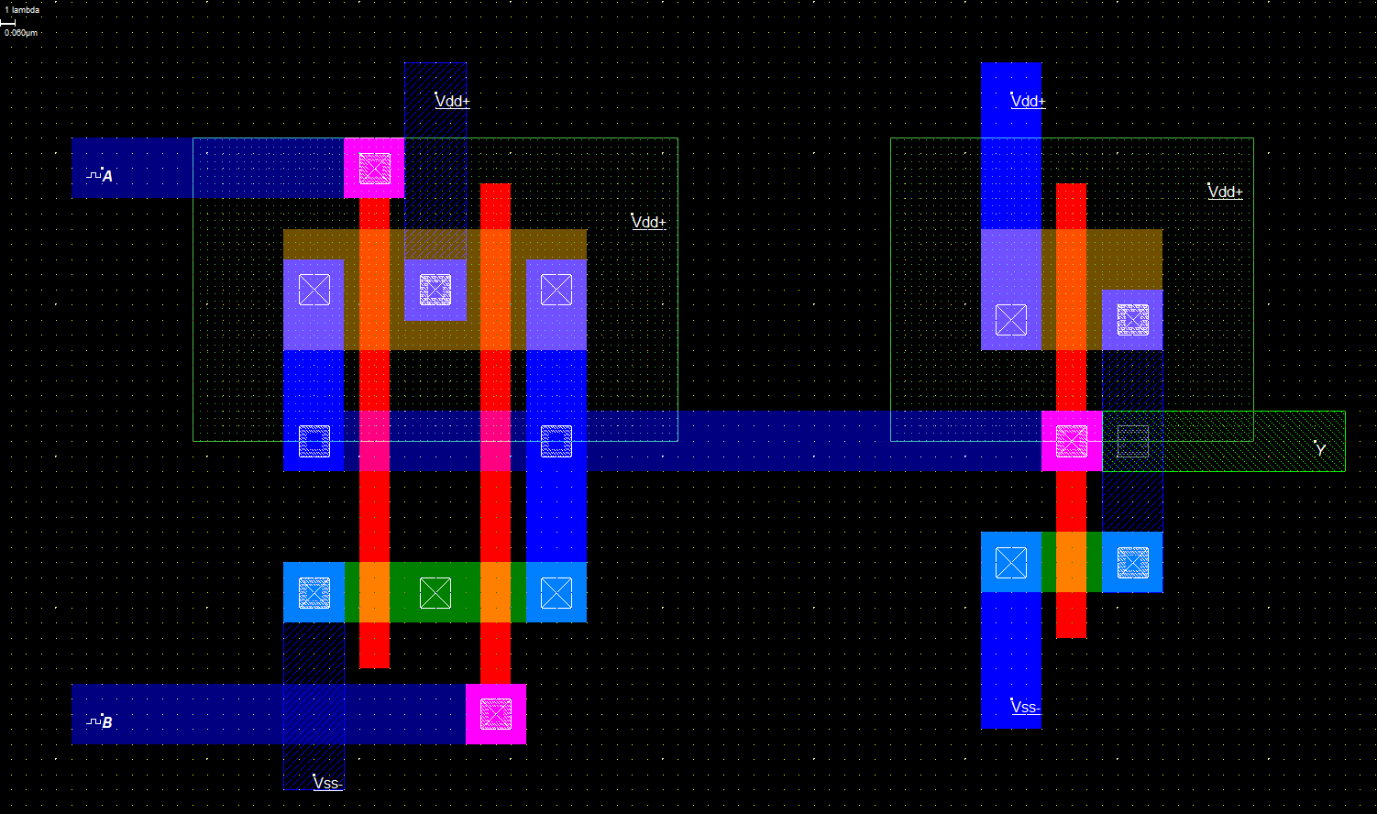

Please insert a picture of working simulation below.
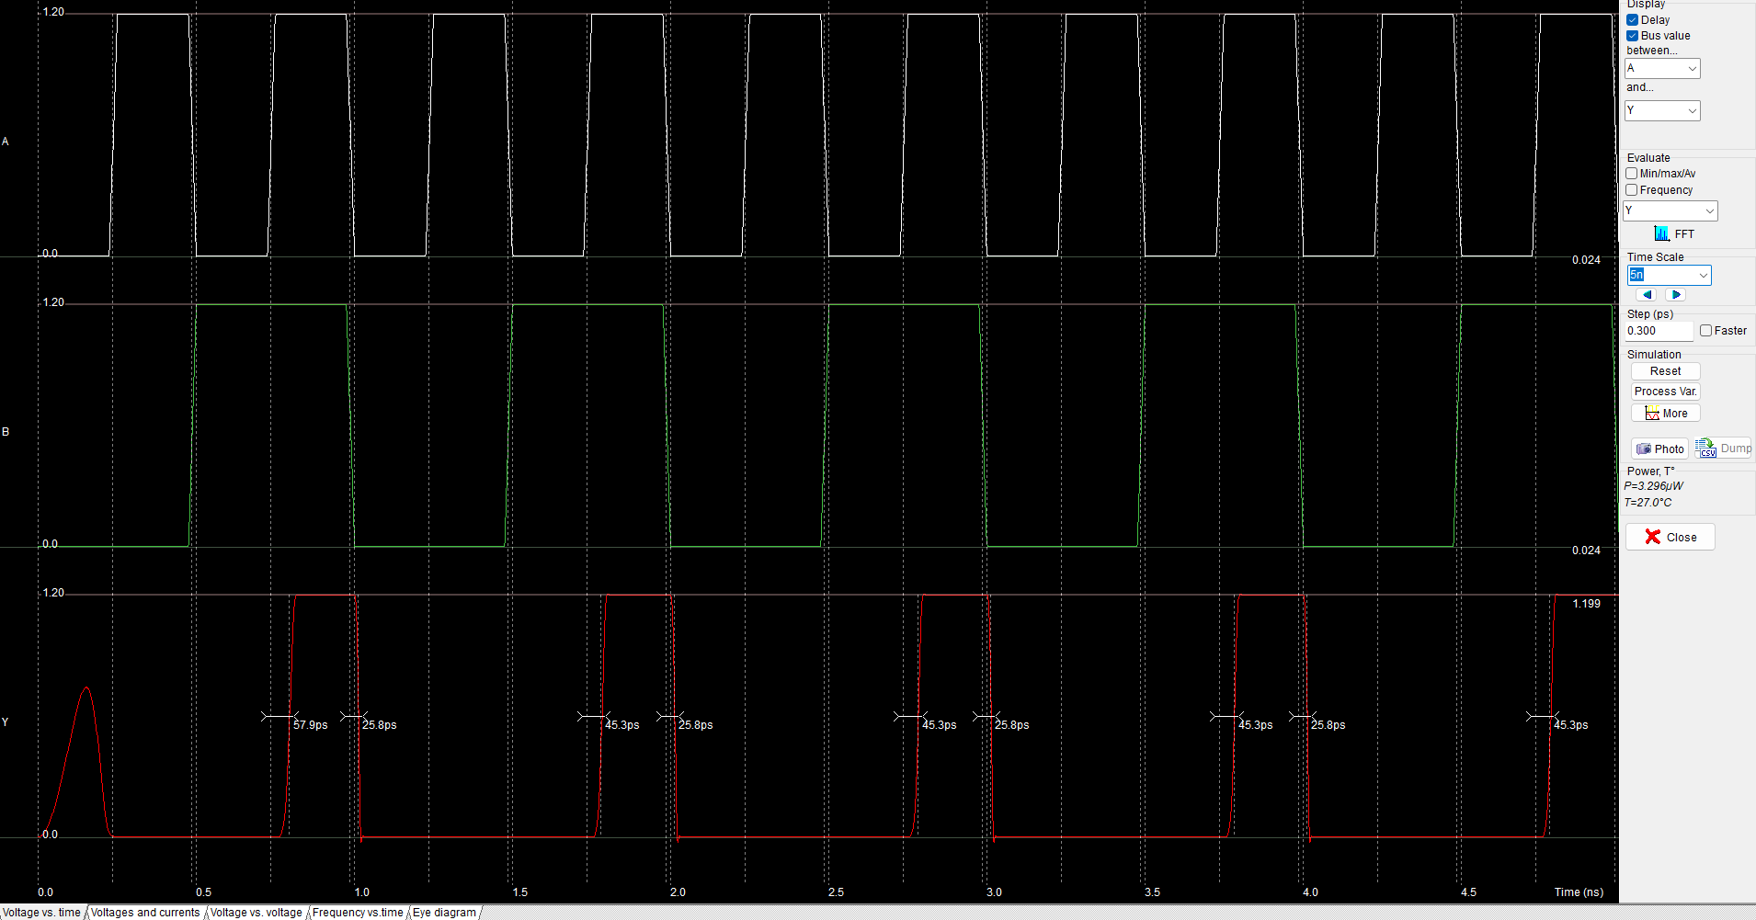
Fill in True Table according to Simulation
A | B | OUTPUT | Accomplished YES/NO
0 | 0 | 0 | YES
0 | 1 | 0 | YES
1 | 0 | 0 | YES
1 | 1 | 1 | YES

Name: Lana Sayes Design Area WxL =________

Design: Inverted NAND Gate CMOS logic 

- Please build design for circled logic above.
- Save design with NAND_ (Your first name).MSK on desktop
- Request Needed designs from other PDs to build your layout
- Send design to person building the next logic when needed.

Please insert a picture of CMOS schematic below.

Please insert picture of DRC clean layout below.
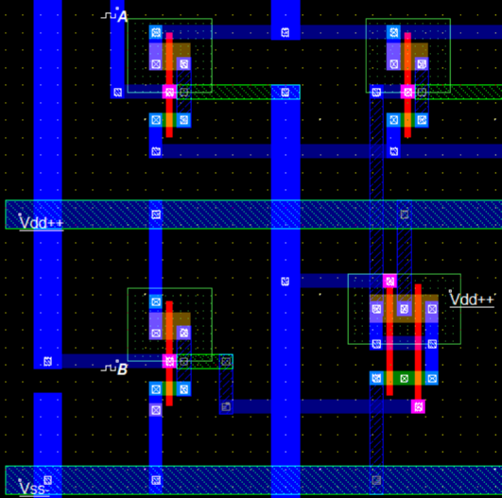

Please insert a picture of working simulation below.
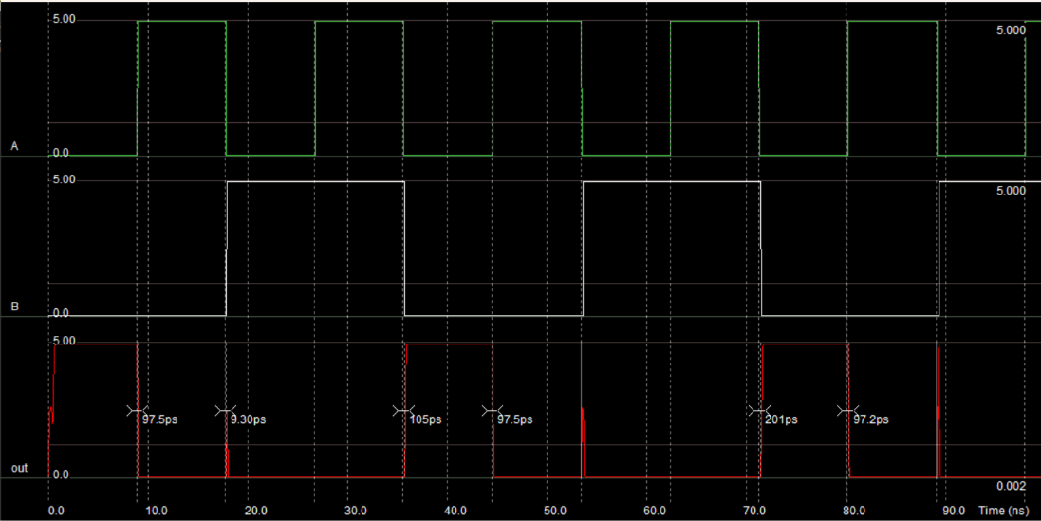

Fill in True Table according to Simulation
A | B | OUTPUT | Accomplished YES/NO
0 | 0 | 1 | YES
0 | 1 | 0 | YES
1 | 0 | 0 | YES
1 | 1 | 0 | YES

Name: Kareem Hamza Design Area WxL =32x40

Design: NOR Gate CMOS logic 

- Please build design for circled logic above.
- Save design with OR_ (Your first name).MSK on desktop
- Send design to person building the next logic when needed.

Please insert a picture of CMOS schematic below.
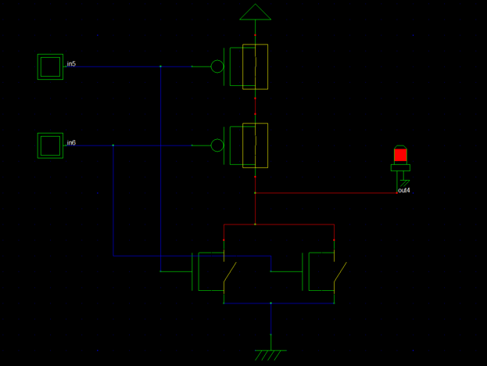
Please insert picture of DRC clean layout below.
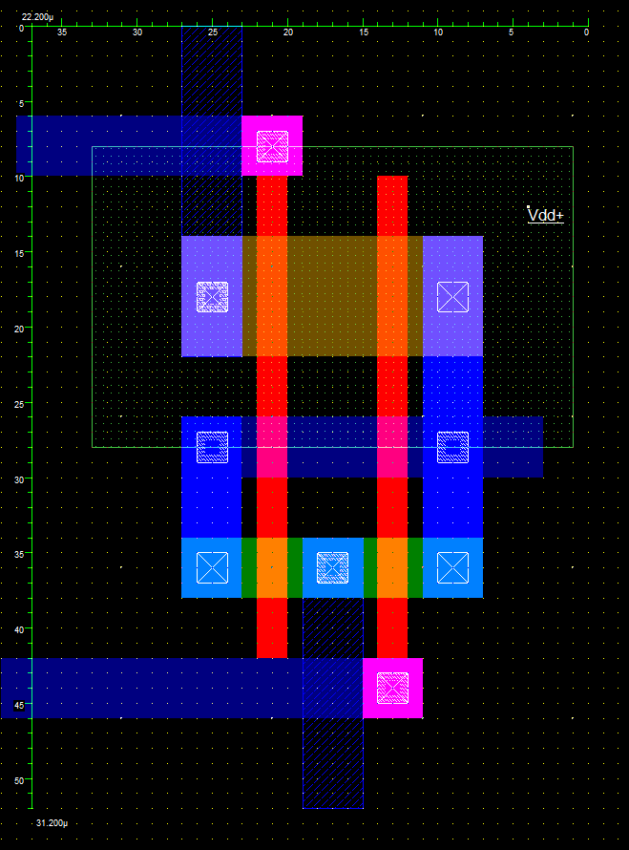
Please insert a picture of working simulation below.
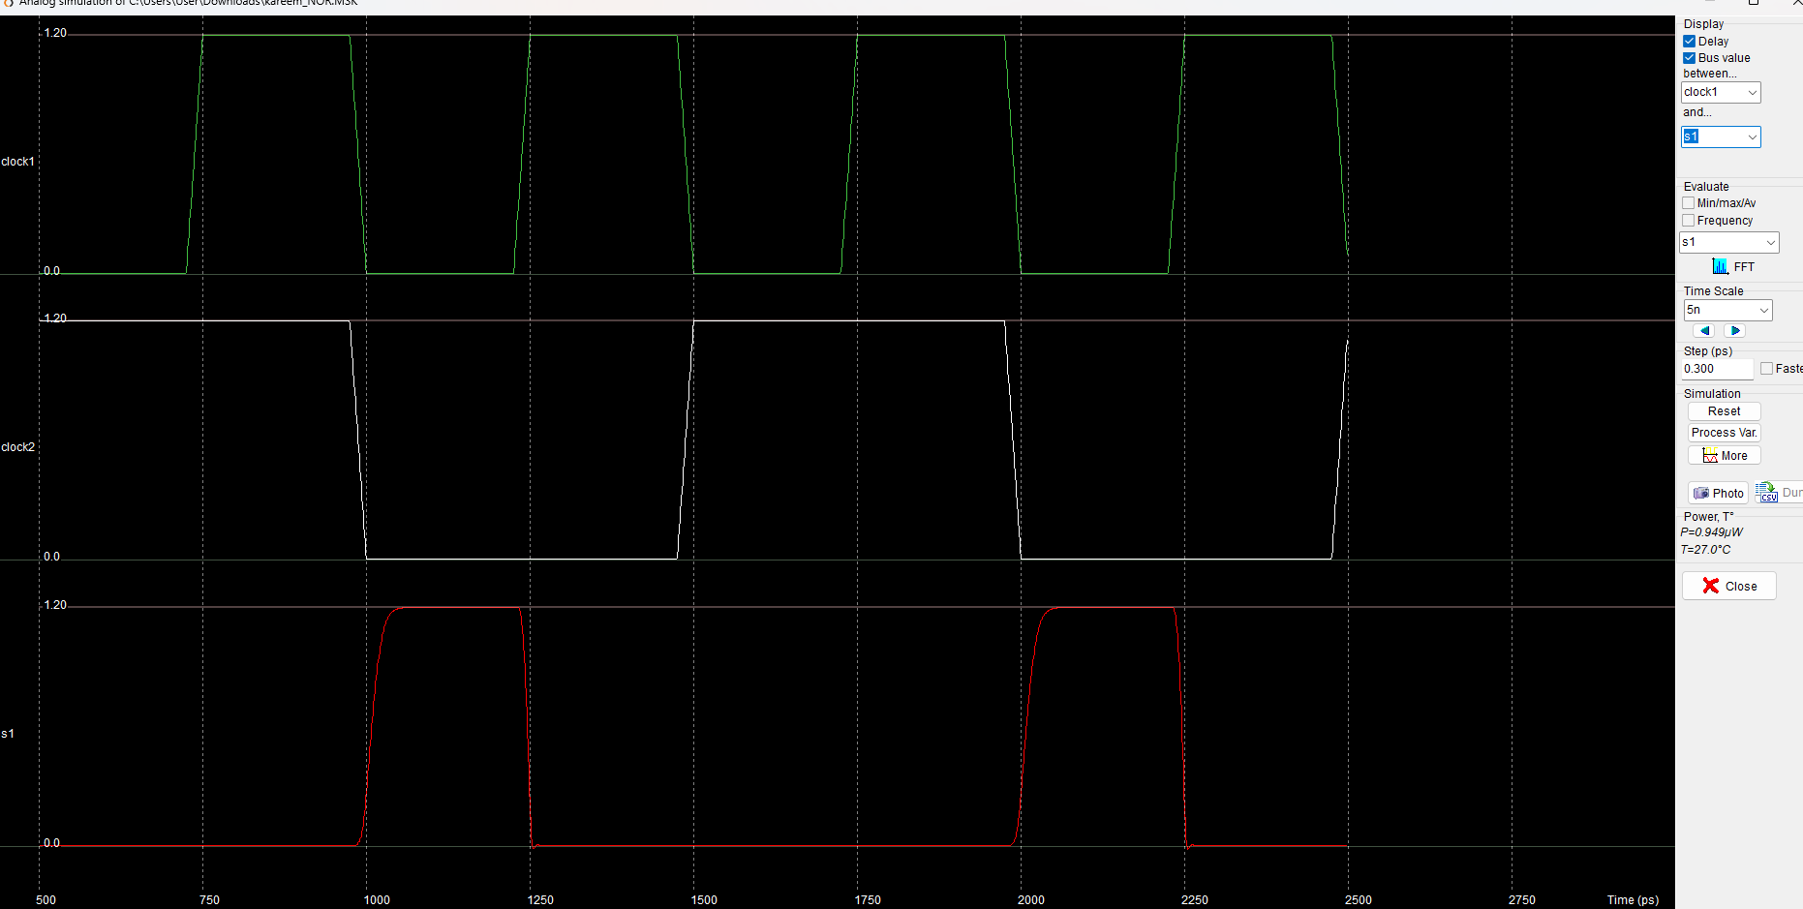
Fill in True Table according to Simulation
A | B | OUTPUT | Accomplished YES/NO
0 | 0 | 1 | YES
0 | 1 | 0 | YES
1 | 0 | 0 | YES
1 | 1 | 0 | YES

Name: Mohyeddin Barghouti Design Area WxL =________

Design: XNOR Gate CMOS logic 

- Please build design for circled logic above.
- Save design with XNOR_ (Your first name).MSK on desktop
- Request needed designs from other PDs to build your layout
- Send design to person building the next logic if needed.

Please insert a picture of CMOS schematic below.

Please insert picture of DRC clean layout below.
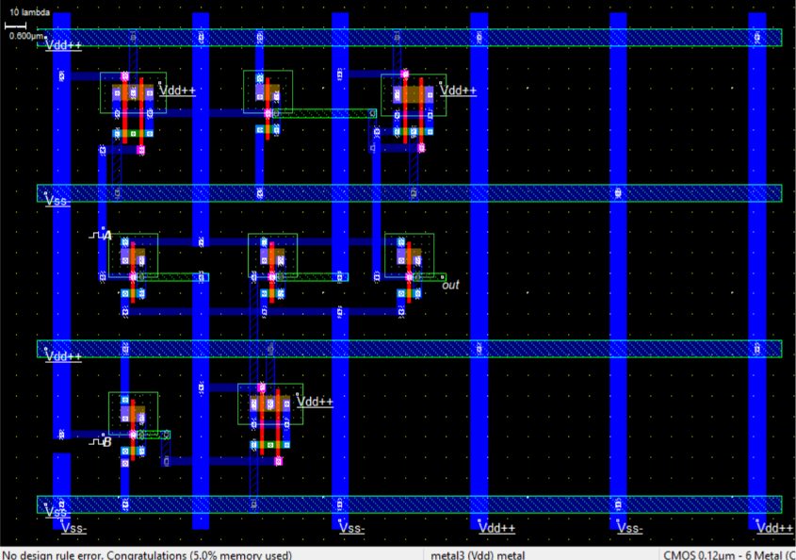

Please insert a picture of working simulation below.
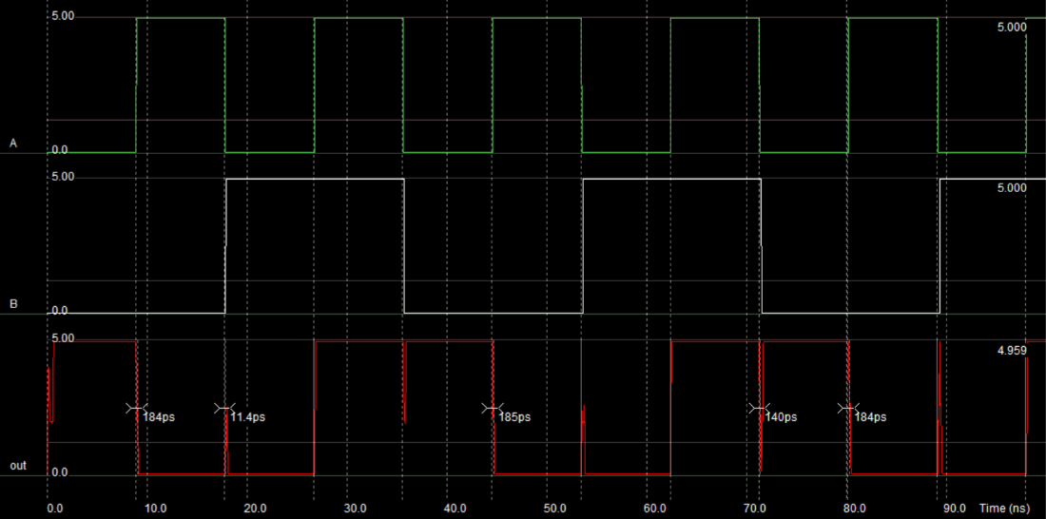
Fill in True Table according to Simulation
A | B | OUTPUT | Accomplished YES/NO
0 | 0 | 1 | YES
0 | 1 | 0 | YES
1 | 0 | 0 | YES
1 | 1 | 1 | YES

